# CHAPTER 1

# INTRODUCTION

## 1.1 Background

The sustained and **rapid global growth of personal and commercial vehicle usage** has intensified the demand for sophisticated, efficient, and high-quality maintenance services. Today’s vehicle owners are increasingly challenged by a highly decentralized service environment, forcing them to spend significant time on manual searches, relying on unpredictable word-of-mouth recommendations, or visiting multiple service centers just to vet quality and compare prices. This traditional, friction-filled process often fails to guarantee that a vehicle will be serviced **promptly or reliably**, contributing to significant inconvenience and frustrating vehicle downtime.

The operational side of the industry is equally challenged. Service centers often use outdated methods for managing a high volume of diverse service requests, struggling with **workflow management, resource allocation, and job tracking**. This lack of internal transparency and automation directly leads to delays, administrative bottlenecks, and, crucially, poor customer communication, which is the fastest route to customer dissatisfaction. In response to these pressing, industry-wide challenges, the **Smart Vehicle Service Center Locator (SVSCL)** is proposed as a technology-driven solution.

The SVSCL aims to fundamentally **streamline the entire vehicle servicing ecosystem** by creating a centralized, digital platform. This integration connects vehicle owners, service centers, and system administrators, enabling the deployment of digital tools that provide **real-time updates, efficient scheduling logic, and systematic, end-to-end tracking** of service requests. By leveraging automation, the SVSCL enhances service transparency, drastically reduces common delays, and delivers a superior, modern customer experience.

## 1.2 Introduction

The contemporary automotive landscape, defined by the **rapid, global growth in personal and commercial vehicle usage**, has generated an unprecedented demand for maintenance services that must be timely, reliable, and high-quality. This essential need has outpaced the capabilities of the traditional vehicle servicing model. Today’s vehicle owners face significant friction points: spending excessive time on manual searches, relying on unpredictable word-of-mouth referrals, and lacking the transparency needed to compare service quality and ensure prompt repairs. This decentralized, antiquated process not only results in inconvenience and frustration for the customer but also exacerbates operational issues for service centers.

Service providers are currently grappling with inefficient workflows, disorganized handling of a high volume of requests, and severe difficulty in **tracking work progress** or allocating resources effectively. Critically, the absence of a unified communication system leads to mismanagement, delays, and a fundamental erosion of customer trust. To address this widening gap between consumer demand for efficiency and the industry's fragmented service delivery, a significant technological shift is mandatory.

The **Smart Vehicle Service Center Locator (SVSCL)** is proposed as the necessary, comprehensive, and technology-driven solution to this systemic problem. By creating a **centralized digital platform** that seamlessly integrates vehicle owners, service centers, and administrators, the SVSCL aims to leverage automation to introduce **real-time updates, intelligent scheduling, and systematic service tracking**. This system will not only drastically streamline the maintenance process—making it easier to locate, book, and monitor service—but will also fundamentally enhance transparency, reduce delays, and establish a new standard for operational efficiency and customer satisfaction within the vehicle service ecosystem.

## 1.3 Problem Statement

Despite the vast number of auto maintenance options available in the market, vehicle owners are consistently hindered by **significant obstacles in accessing timely and reliable services**. The core problem is the **absence of a unified, centralized system**—a digital hub that orchestrates the service process. This fragmentation results in inefficient, one-way communication channels, unacceptably **long waiting times**, and a fundamental **lack of transparency** regarding service milestones, repair costs, and estimated completion times.

From the perspective of service providers, this lack of centralization leads to a significant operational burden. Service centers struggle to efficiently prioritize and manage a large volume of concurrent service requests, making it difficult to **allocate specialized resources** (like certified technicians or specific service bays) effectively. Maintaining consistent, proactive communication with every customer becomes a major administrative strain, often leading to missed updates and customer confusion. These collective and intertwined challenges culminate in a **fragmented, inconvenient, and untrustworthy vehicle servicing experience**. The SVSCL is specifically designed to bridge this gap by establishing a **unified digital platform** that not only streamlines service request management but also facilitates real-time, transparent communication, significantly enhancing the **operational efficiency** and overall maintenance experience for all providers.

## 

## 1.4 Motivation

The necessity to create the Smart Vehicle Service Center Locator is based on the necessity to modernize and streamline vehicle maintenance to the demands of a more connected and mobile world. This project is inspired by a twofold agenda; to do away with uncertainty and inconvenience to vehicle owners and at the same time, to fix the chaotic workflow and failure of communication among service providers.

Through the use of a centrally managed, technology-focused platform, the SVSCL aims to enforce novel industry standards of accessibility, transparency, and efficiency. The design of the system is motivated by the idea to provide the simplification of the whole life cycle of the services offered, i.e., easily finding a reliable service center and placing an appointment, to monitoring the status of the request in real time. This made this trip very easy and saved a lot of time to the vehicle owners and helped in alleviating a lot of frustration. In the case of service centers, the platform will have significant benefits: more efficient management of resources, smoother control of service requests, and more efficient and active communication with customers. This is the essence of the SVSCL as more organized, efficient, and truly user-friendly vehicle service ecosystem is intended to be developed by leveraging this duo of benefits of adding convenience to the end-user and streamline operations to the enterprise.

## 1.5 Scope

The range of the Smart Vehicle Service Center Locator (SVSCL) consists of the overall creation and deployment of an all-embracive digital platform serving the entire service requirements of vehicle owners, service centers and system administrators. To the owners of vehicles, the system has what they need such as a secure user registration, advanced tools of finding nearby service centers in accordance with unique requirements (such as service type or ratings), ability to place service orders, real-time monitoring of a vehicle status, the ability to make digital payments, and necessary feedback on the services provided.

The service center scopes focus on efficiency. They have the power to handle incoming requests via a special dashboard, keep track of service progress in an open and transparent manner, have correct service menus and pricing, and use built-in means of direct communication with customers. In addition, administrators control the whole ecosystem, all users and centers and create necessary performance reports. The SVSCL is designed to affect the entire system by incorporating real-time updates, centralized management, and advanced user-friendly features that will significantly decrease delays, increase the accountability of the services offered, and create a smooth and modern experience

to all stakeholders engaged in the vehicle maintenance process.

# CHAPTER 2

# LITERATURE REVIEW

## 2.1 Swarali Degaonkar, Manasi Khillare, and Dr. Aarti Agarkar (2023) – IJARIIT

**Title:** Vehicle Service Automation

The widespread disintegration and technical standstill in the automotive service market requires a special, advanced digital intervention, which essentially justifies the aim of the supportive study, the title of which is "Vehicle Service Automation." The central aspect of this paper is the necessity of having a platform that is able to realize excellent efficiency in the process of finding specialized maintenance and service shops of both two-wheelers and passenger cars, and directly resolves the epicenter of consumer pain, being discovery and vetting in a decentralized market. The proposed system goes further to go beyond the mere listing of directories by incorporating new Geographic Information Systems (GIS) whereby the location of the users becomes the main and most decisive data element of providing the best recommendation via the web application.

More importantly, within a sector where asymmetry of information and low consumer trust has been the bane, the system, through its Rating, and reviews, becomes a force of creating transparency and community-imposed accountability, enabling potential clients to evaluate and compare the past quality of service delivery before making the commitment of resources. This consumer empowerment is even more refined with the tactical incorporation of proactive utility functions namely, the capacity to make notification of pending car service or PUC update which not only makes the application look like a scheduling tool, but a proactive, holistical vehicle maintenance assistant, which keeps everything within the bounds but avoids the most critical parts of maintenance oversight.

**Relevance to AutoConnect – Smart Vehicle Service Center Locator:**

The Relevance to AutoConnect - Smart Vehicle Service Center Locator (SVSCL) is thus absolute, which proves that the strategic focus that the current study has chosen simplifying the process of finding and communicating with local car service centers is not only analogous to the mandate of the SVSCL, but it is its blueprint of operation. The literature review clearly demonstrates the overall thesis that the combination of automation capabilities, is the key to the simultaneous fulfillment of the dual objective of increasing the levels of convenience, thus, directly addressing and confirming the overall goals and functionalities of the proposed SVSCL system.

## 

## 2.2 Laxman Krishnan, Arathy S, and Haritha K (2021) – IJARIIT

**Title:** GPS-Based Emergency Vehicle Detection System

Current technological literature on automated location-based systems offers an attractive framework to the essence of the functionality of the Smart Vehicle Service Center Locator (SVSCL), which is a requirement that is highly upheld on the principles developed in the supportive work, GPS-Based Emergency Vehicle Detection System. This ground paper is strictly constructed by establishing the operational paramountcy of real-time geospatial awareness in high-stakes environments, in which high-precision GPS technology is integrated with communication networks to enable the dynamic detection and tracking of critical assets to enhance the response efficiency to a high degree in exigent circumstances. The principles that are stipulated, namely the need of dynamic data transmission protocols and the need of provision of an active and instantaneous contextual notification, are not only similar to, but are also crucial technology-wise elements towards the success of the SVSCL.

**Relevance to AutoConnect – Smart Vehicle Service Center Locator:**

The applicability makes itself clear in case high-fidelity location tracking and automatic data transmission can minimize delays and allow achieving faster access to emergency services, the SVSCL should employ the same sophisticated location heuristics to achieve the maximum service efficiency and user comfortability in the maintenance industry. The SVSCL is able to maximize user navigation by mapping the priorities of the emergency system of automated transmission of data onto a service situation in order to bring the customer into the most effective channel toward the desired service center, which is capable of reducing the systemic response time and minimizing the time spent updating the vehicle. Overall, the SVSCL modifies an already successful technology in terms of enhancing critical, time-sensitive coordination and re- packages its use to improve the accuracy of operations and logistical efficiency of vehicle service management. The reported effectiveness of GPS integration in improving service coordination and operational accuracy, which are the key pillars of the Emergency Vehicle Detection study, prove the fact that those technologies are not extraneous but the primary components that cannot be omitted in order to maximize efficiency and reliability of all the components of the SVSCL system, which prove that it is designed as the highly responsive, location-aware digital platform that modernizes the whole automotive service ecosystem.

## 

## 2.3 Sathwik Krishna L and Siva Rama Krishna S (2021) – IJSRCSEIT

**Title:** Vehicle Breakdown Service Provider System

The article named Vehicle Breakdown Service Provider System offers essential technological confirmation through the implementation of the creation of a digital platform that is designed to outperform and eliminate the logistical mess of any form of unexpected vehicle breakdown situation. The main idea of such a system is to create an immediate and a smooth linkage between the stranded vehicle owners and the closest service professionals, which is the need that provides the significance of instantaneous location-based service distribution. The architecture presented in the paper focuses on a strict series of operations, where the secure registration of users and the automatic creation of the service request will initiate the process of assigning services to a sophisticated service provider selection process, which will be strictly guided by the proximity and the current availability. More importantly, the paper carefully points out the critical role of complete automatization and real-time communication as the main factors contributing to the reduction of the unavoidable response time in the abacus of roadside emergencies. This study establishes that technology is the most important tool towards enhancing high efficiency in the operations of the service provider and customer satisfaction at peak levels during high-stress and time-sensitive roadside services, by making the complex coordination between distressed vehicle users and service providers simple and streamlined.

Relevance to AutoConnect – Smart Vehicle Service Center Locator:

The results and design concepts in the Vehicle Breakdown Service Provider System are directly and significantly related to the essence of the goals of the AutoConnect - Smart Vehicle Service Center Locator (SVSCL) since the two sites are linked to a specific objective of allowing users to be connected to service centers based on their locations and efficiently. Specifically, the breakdown research highlights the quantifiable worth of automated service matching and speedy response mechanisms, which have proven to be non-negotiable success factors of time-sensitive service provision, which is a critical functional requirement that AutoConnect fully embraces. This paper confirms that SVSCL made the right choice in the selection of proximity and availability as the fundamental principles on which the scheduling engine of the target company would be based, so that the users were not only assigned to a possible center, but were matched with the best resource to meet their urgent activity. By illustrating how technology may reduce the amount of human effort and guarantee prompt professional assistance in case of emergency, the breakdown system provides the unambiguous data that the same automated principles, applied to a planned maintenance and repair care, will significantly increase the reliability rates, reduce user friction, and build the system of guaranteed quality service delivery within the AutoConnect ecosystem.

## 2.4 M. A. R. Kumar and K. N. Rama Krishna (2022) – *i-manager’s Journal*

**Title:** Automatic Car Service Recommendation System

The article called Automatic Car Service Recommendation System is a big step in the digital service environment as it suggests a smart, data-driven system that can radically change the reactive maintenance into an active one. The essence of the suggested system lies in the application of advanced data analytics and machine learning algorithms that will help correctly determine the maintenance needs on the basis of a multi-faceted dataset, such as the current state of the vehicle, the patterns of its use, and clearly stated user preferences. Through the use of predictive analytics, the system will be designed to help predict possible mechanical problems and maintenance requirements, thus allowing the system to automatically produce the appropriate service suggestions and communicate them to the users well beforehand. The methodological benefits that can be made quantifiable are as follows: the overall performance of the vehicle is improved, the number of risks related to an unexpected breakdown is reduced significantly, and the convenience of the use is enhanced greatly. Finally, this paper illustrates a strong case of how digital automation, driven by predictive intelligence, can effectively transform the conventional, usually tedious, vehicle servicing procedure into an exceptionally efficient, proactive, and data-based maintenance process.

Relevance to AutoConnect – Smart Vehicle Service Center Locator:

The research results of the Automatic Car Service Recommendation System are critically tuned to the high-tech architectural vision of the AutoConnect - Smart Vehicle Service Center Locator (SVSCL), namely, the transformative aspect of automation and intelligent control of services in streamlining the customer experience. The suggested development of predictive service recommendations integration will be a rational and potent extension of the existing functionality of the SVSCL, which is created on the basis of instant location matching. Through the use of the advanced data analytics outlined in the paper, AutoConnect will be able to not only connect a user with a service center nearby, but it can determine the correct service center at the correct moment- even before a failure takes place. This predictive feature leads to timely, as well as needed maintenance. Luckily, the present research offers the necessary intellectual foundation to integrate machine learning into the quest to bring the SVSCL to a new level of intelligent service location and to the sphere of intelligent, anticipatory vehicle lifecycle management.

## 

## 2.5 Dinesh S. Bhadane and Pritam B. Bharati (2023) – ResearchGate

**Title:** Review on GSM and GPS Based Vehicle Tracking System

The article is called Review on GSM and GPS Based Vehicle Tracking System and provides an in-depth and a baseline analysis of the developed technological framework of dynamic vehicle tracking. The paper stringently explains how the Global Positioning System (GPS) modules and Global System for Mobile communications (GSM) modules mutually enact each other, namely, the GPS component accurately establishes granular and real-time geographic positioning of the point, and the GSM element is the necessary communication medium, transmitting the vital location information in real-time to the centralised servers or mobile handsets of users. The authors point to the physical benefits of such integrated tracking systems, namely mentioning how they have proven useful in helping to improve vehicle monitoring functions, introducing complex route optimization plans, and overall management safety measures to a considerable degree. Moreover, the review presents a fair assessment by critically examining implementation obstacles that are practical in these technologies, including solving the issue of reliability of signal, attaining economies of scale, and scalability of the system, which is important to long-term sustainability of any location-aware platform.

Relevance to AutoConnect – Smart Vehicle Service Center Locator:

This full Review on GSM and GPS Based Vehicle Tracking system gives necessary technical verification and support to the basic technological framework of the AutoConnect - Smart Vehicle Service Center Locator (SVSCL). The study categorically proves the central value of GPS-enabled tracking and intensive data transmission to be inseparable components of any modern vehicle management software. AutoConnect directly builds upon the proven concepts described in the review, utilizing similar technologies to fulfill two main functional requirements, the first one being that of properly detecting and locating nearby service centers with respect to the dynamic user position, the second one being that of efficiently steering the user through optimized navigation tracks to his or her preferred destination. The SVSCL directly promotes its main objective, which is to provide accurate and real-time location-based services, by embracing a high-reliability standard that is exhibited by built-in GSM/GPS systems. It is this compliance with established tracking techniques that is key to improving user convenience, geographical precision, and responsiveness in the important stages of vehicle maintenance and service processes in the platform.

## 

## 2.6 Dr. Raghu R and Dr. Mala K. M. (2023) – IJARIIT

**Title**: Integration of GPS in Emergency Service Vehicles

The article, which is entitled Integration of GPS in Emergency Service Vehicles, provides a critical technical analysis of installing Global Positioning System technology into the most mobile, mission-critical response floors. The key theme is showing how this integration significantly improves the precision of navigation, the effectiveness of responding to incidents, and the achievement of inter-agency coordination in the process of handling complex incidents. The described system architecture supports advanced functionality, such as real-time vehicle tracking and real-time route optimization, which are crucial features that allow the control centers to maintain communication between themselves and the assets to successfully deploy resources and ensure that the arrival time is minimized. The article is unapologetic about the fact that strategic incorporation of GPS in the overall vehicle management systems is not just a luxury but a requirement in order to achieve maximum amounts of operational visibility and that it has been deployed to directly support the use of data in making choices and hence has brought a clear and high level of performance benchmark to all location-sensitive service logistics.

Relevance to AutoConnect – Smart Vehicle Service Center Locator:

This study is a convincing and clear justification of the fundamental engine behind the functionality of the AutoConnect - Smart Vehicle Service Center Locator (SVSCL) in that it explicitly shows the enormous capacity of GPS-based integration to essentially enhance both the accuracy of location and coordination of services-principles that are the technology behind the SVSCL platform. Through a careful application of the identical crisis-tried, high-resilience tracking and route optimization quality criteria utilized in emergency situations, AutoConnect greatly improves the accuracy of its geolocation of nearby service centers in addition to optimizing user-based routes to planned or urgent maintenance requirements. This is a strategic acquisition of proven GPS technology that guarantees a smooth, highly responsive and well-coordinated experience in service delivery, which is directly aimed at the ultimate goal of the SVSCL which is to create a significantly more efficient and reliable automotive support network than the system set up by old fashioned service directories.

## 

## 2.7 Acharya, M. (2023) – ScienceDirect

**Title:** A Long Short-Term Memory (LSTM) approach for POI (Point-of-Interest)

Long Short-Term Memory (LSTM) approach to POI (Point-of-Interest) Recommendation, the paper presents a new advanced methodological change, suggesting the application of LSTM networks as a specific type of recurrent neural network architecture and spatial-binning to create the most relevant and personalized POI recommendations to users. The key innovation is that the system can go past mere proximity matching and dynamically integrate a combination of both temporal (when a user moves or requests services) and spatial (where they tend to go) patterns. The advanced modeling enables the algorithm to comprehend complex user motility and purpose, which enhances the individual location suggestions availed greatly. This study creates an impressive framework of how deep learning can be used to provide predictive and contextual recommendations in a location-based service platform by effectively charting user-specific historical data and contextual factors.

Relevance to AutoConnect – Smart Vehicle Service Center Locator:

The present study provides strong strategic significance to the sophisticated design of the AutoConnect - Smart Vehicle Service Center Locator (SVSCL) because it will strengthen the background significance of GPS based tracking besides the intellectual basis of intelligent service matching. Precise recommendation methods introduced such as the use of spatial binning with the study of temporal user activity can be easily incorporated and integrated into the architecture of SVSCL. This integration enables the system to go beyond just finding the nearest service center the system will now be intelligent in suggesting the best nearby center depending on factors such as the time of the day, the immediate location of the user as well as their previous maintenance habits. The predictive capacity of the SVSCL can be applied to radically streamline the delivery of services, making these relationships exceptionally personal and preemptive by anticipating the next probable need or preference of the user and service centers producing the most convenient and efficient operation. By predicting the user's next likely need or preference, the SVSCL can use this predictive capacity to dramatically optimize service delivery, resulting in highly personalized and preemptive connections between users and service centers, thereby maximizing convenience and operational efficiency.

## 2.8 Seyedi, P. (2024) – ScienceDirect

**Title:** Introducing a decentralized integrated Online Booking (IOB) system

This paper, introducing a decentralized integrated Online Booking (IOB) system, is more of an architectural study, where the authors have proposed a strong design blueprint of the management of high volume and concurrent appointment scheduling. The essence of this proposed system is the incorporation of the decentralized components so as to achieve the system resilience and high availability, especially in high demand environments. The critical component of the system that contributes to its success is its advanced queue management and slot allocation model modeled with the aim of minimizing wait time and maximizing the use of resources in the traditional appointment-based system. The study offers a good conceptual framework in addressing the complex computational problems of managing the shared resource pool (such as service bays or technicians) in more than one location hence assuring system integrity and optimization of throughput in service delivery.

Relevance to AutoConnect – Smart Vehicle Service Center Locator:

This study has considerable and direct technical importance on the design of the AutoConnect - Smart Vehicle Service Center Locator (SVSCL) especially insofar it objectifies and discusses vital architectural concepts of the SVSCL booking engine. With the paper, one can learn invaluable insights on how to cope with complexities of operation of managing concurrency and effective slot allocation-mechanism that is imperative in ensuring that service centers do not run in a state of overbooking or resource bottleneck. The elements of the decentralized design and the principles of the queue management that are outlined in the IOB system are the key to thinking strategically about the process of scaling the booking subsystem in the SVSCL. Having these architectural ideas in place, the SVSCL will be able to ensure the integrity of service requests and guarantees credible time allocation to the service users and also assure that centers have correct and controllable daily schedules, hence a frustratingly smooth experience in service bookings.

## 2.9 Rahman, Perez, others. (2024) – BM Journal

**Title:** The Impact of Reviews and Ratings on Customer Decisions

The article is entitled The Impact of Reviews and Ratings on Customer Decisions, and it is a critical research study of the psychological and economic implications of the user-generated feedback in online service situations. The fundamental observation confirms the fact that high ratings play a big role in customer preferences and trust making aggregated community consensus as a significant factor in how people choose the service. Of vital importance, the study indicates that mere presentation of scores is not enough; to have any significant effect on improving the reliability of the platform, complex mechanisms to perform aggregation on ratings and verification of reviewers is required. This paper presents the empirical reasoning behind the implementation of user governance and trust-building functionalities in service-locator platforms by explaining how transparency and accountability established by means of effective feedback mechanisms will lead to a fundamental shift in consumer perception.

Relevance to AutoConnect – Smart Vehicle Service Center Locator:

This study has direct and essential applicability to the architectural and strategic business of the AutoConnect - Smart Vehicle Service Center Locator (SVSCL), especially on clarifying why it is necessary to adopt solid feedback systems. The results directly support the fact that the main engine of enhancing user trust and directly boosting the rate of booking with the most competent service providers is the implementation of a powerful rating aggregation, transparent display, and reasonable moderation. This study is required to serve as a guideline to AutoConnect, in the way this company should present the ratings, and far more importantly, the method in which it must filter the low-quality or fraudulent reviews by verifying the information provided. The adoption of these best practices will keep the SVSCL users make decisions founded on verifiable service quality and therefore build a high-trust environment which eventually rewards excellent service centers and justifies the decision made by the customer.

## 2.10 S. Shankar Kumar, K.J. Vinodini. (2024) – IIETA

**Title:** Assessing Accessibility and Inclusivity in Digital India Services: A Citizen’s Perspective.

The article, Assessing Accessibility and Inclusivity in Digital India Services: A Citizen Perspective, presents an important, bottom-up study of the practical issues faced by the citizenry in accessing and using digital public service models within the huge Digital India project. Based on the practical experience of users in Tamil Nadu, the research systematizes the identification and documentation of critical barriers of the system that obstruct the intended effectiveness of these online services. At the top of the list of findings is the fact that there are serious usability problems, since complicated interfaces and bad design will hinder easy interaction; awareness, since potential users cannot even recognize the existence of the platforms due to the absence of effective outreach; and structural inclusivity problems, which will push citizens aside, no matter their level of technical competence or background. The present research is crucial because it helps to estimate the gap between digital policy at macro-level and the micro-level of the actual digital experience, which states that adoption of technology is inherently determined by the fair and user-friendly system design.

Relevance to AutoConnect – Smart Vehicle Service Center Locator:

The core and practical implication of this study of the digital accessibility of services in digital research on digital service accessibility is extremely significant to the case of AutoConnect - Smart Vehicle Service Center Locator (SVSCL) since the SVSCL is essentially a new digital public service working in the Indian market environment. The fact that the study focuses on the need to make the service more accessible and user-experience (UX) friendly is immediately translated into the non-negotiable design requirement at AutoConnect. In particular, it solidifies the idea that the platform should be designed with the use of Universal design principles, so that all citizens regardless of their technical background or level of digital literacy may easily access such convoluted features as the possibility to book vehicle services and track them in real-time. Through a deliberate effort to resolve the specified usability and inclusivity issues, AutoConnect will be able to reduce the points of friction, increase the percentage of users adopting the provided technical solution across various demographic groups, and make the advantages of the automated service management equally accessible, thus turning its technical solution into a highly inclusive service platform.

# CHAPTER 3

# PROPOSED SYSTEM

## 3.1 User Management Module

The **User Management Module** serves as the primary interface for vehicle owners who utilize the AutoConnect platform to locate and interact with nearby service centers. This module enables users to register, log in securely, and manage their personal profiles with ease. It forms the foundation of user interaction within the system, allowing individuals to access various services and maintain their vehicle-related data digitally.

Key features of this module include **user registration, authentication, and profile management**. Users can create accounts by providing essential details such as name, contact information, and vehicle data. Through this module, users can update their profiles, view booking history, and track ongoing service requests. The system ensures data privacy through **secure login credentials and encrypted data handling**, maintaining confidentiality and protecting sensitive information.

Additionally, the module provides a personalized experience by allowing users to set preferences, view service recommendations, and access location-based service options. By integrating these functionalities, the User Management Module enhances accessibility and convenience, ensuring that users can efficiently connect with service providers. Overall, it serves as the foundation of AutoConnect’s interactive framework, promoting seamless communication between users and service centers while ensuring transparency and security in operations.

## 3.2 Service Center Management Module

The **Service Center Management Module** is designed to assist service providers in efficiently managing their workshops, services, and customer interactions through the AutoConnect platform. It acts as the operational hub for service centers, enabling them to maintain an updated digital presence and streamline their administrative processes.

Core functionalities include **registration and authentication of service centers**, allowing verified providers to create and manage their profiles. Service centers can **list available services**, update pricing, specify working hours, and indicate real-time availability. The module also enables providers to receive and respond to booking requests, manage appointment schedules, and communicate directly with customers for confirmations or queries.

Furthermore, service providers can track customer reviews and ratings, allowing them to assess performance and improve service quality. The system ensures secure access through **role-based authentication**, enabling only authorized personnel to manage operations. By integrating these features, the Service Center Management Module enhances efficiency, transparency, and responsiveness, ultimately strengthening customer trust and satisfaction.

## 3.3 Booking & Scheduling Module

The **Booking & Scheduling Module** is a key operational component of AutoConnect that facilitates seamless appointment management between users and service centers. This module ensures that users can conveniently **book, modify, or cancel service appointments** while enabling service centers to **manage their schedules** effectively.Users can view the list of nearby service centers based on GPS location, select a suitable one, and choose preferred dates and times for their appointments. Once booked, the system automatically updates the service center’s availability and notifies both parties of the confirmed appointment. It also allows **real-time status tracking** of ongoing services, helping users stay informed about service progress.

From the service center’s perspective, the module simplifies workload management by preventing overbooking and ensuring optimal resource utilization. Automated notifications and reminders minimize missed appointments and delays. Overall, the Booking & Scheduling Module enhances operational efficiency, improves user convenience, and supports time-bound service delivery, which is central to AutoConnect’s objective of streamlined vehicle service coordination.

## 3.4 Review & Rating Module

The **Review & Rating Module** enhances the transparency and accountability of the AutoConnect platform by allowing users to provide feedback on the services received. After a service is completed, users can **rate the service center** based on parameters such as quality, timeliness, and customer experience, and can also provide written reviews.

Service centers can view this feedback to understand customer satisfaction levels and identify areas for improvement. The system may also use aggregated ratings to generate overall service scores, helping new users make informed decisions when choosing a service provider.

This module contributes significantly to maintaining service quality and competitiveness within the platform. By promoting genuine user feedback and visibility of performance, the Review & Rating Module builds trust between customers and service centers, ensuring continuous service improvement and user satisfaction.

## 3.5 Admin Module

The **Admin Module** is the central control component of AutoConnect, responsible for overseeing all user and service center activities, maintaining data integrity, and ensuring smooth system operations. Administrators manage platform access, monitor service transactions, and handle system-wide updates to maintain functionality and security.

Key features of this module include **user and service center management**, **report generation**, and **system monitoring**. Admins can verify new service center registrations, resolve user complaints, and deactivate fraudulent accounts when necessary. The module provides administrators with comprehensive dashboards displaying real-time analytics on bookings, ratings, and system usage trends.

Additionally, the Admin Module ensures proper communication across all modules by disseminating notifications, handling escalations, and maintaining system performance. Through secure and role-based access, administrators can implement policies, review feedback summaries, and plan service improvements. Overall, the Admin Module is vital for maintaining platform transparency, ensuring data accuracy, and supporting efficient operation of the AutoConnect ecosystem

# CHAPTER 4

# METHODOLOGY

## Introduction

The methodology adopted for the development of the **AutoConnect: Smart Vehicle Service Center Locator** follows a structured, systematic, and user-centric approach to ensure that the system is reliable, scalable, and efficient. Since the project serves multiple stakeholders — including **vehicle owners, service providers, and system administrators** — the methodology focuses on clear requirement analysis, effective system design, secure implementation, and continuous testing and improvement.  
This chapter describes the research and development methodology adopted in the project in a detailed and structured manner.

The project adopts an **Applied Research Design** supported by a **Software Development Life Cycle (SDLC)** framework. The applied research focuses on solving real-world challenges in vehicle servicing such as **delays in locating nearby service centers, lack of transparency in service pricing, and inefficient booking management**. The SDLC framework provides a systematic roadmap to plan, develop, and test the system effectively.

The **Agile Methodology** (particularly **iterative and incremental development**) has been adopted for this project. This approach allows flexibility and continuous refinement of the system based on user and stakeholder feedback. Agile ensures that each module — from service center registration to booking management — is developed, tested, and integrated iteratively, ensuring the final system is user-friendly, responsive, and functionally robust.

## Functional Requirements

The AutoConnect system is designed to support three main user roles — **Administrator**, **Service Provider**, and **User (Vehicle Owner)**.

**Administrator:**

* Manages user and service provider accounts.
* Monitors system activities, resolves issues, and ensures data accuracy.
* Oversees booking statistics, reviews, and service feedback.
* Generates analytical reports on service usage, trends, and user behavior.

**Service Provider:**

* Registers their service centers with details like location, services offered, and timings.
* Manages appointments and updates service availability.
* Responds to user bookings and service requests.
* Updates service progress and completion status.

**User (Vehicle Owner):**

* Registers and logs into the system securely.
* Views and locates nearby service centers based on GPS.
* Books service appointments and tracks their service status.
* Submits reviews and ratings for service centers.

**Non-Functional Requirements**

* **Security:** Implements encrypted data storage, role-based access control, and secure authentication.
* **Scalability:** Capable of handling a large number of users and service providers as the platform expands.
* **Performance:** Ensures fast search, booking, and real-time service tracking with minimal latency.
* **Usability:** Provides an intuitive interface with easy navigation and responsive design for different devices.
* **Reliability:** Guarantees accurate data retrieval and system uptime through database integrity and automated backups.
* **Availability:** Operates 24/7 to ensure users can access the service at any time.

## System Design

The **System Design** of the AutoConnect application defines its architecture, data flow, and module interactions to ensure efficient functionality and maintainability.

The system follows a **three-tier architecture** comprising:

* **Presentation Layer:** Handles user interaction through web and mobile interfaces for users, service providers, and admins.
* **Application Layer:** Contains business logic for search, booking, scheduling, and feedback processing.
* **Database Layer:** Stores and retrieves all necessary data including user profiles, service details, bookings, and feedback using a relational database (MySQL/SQLite).

The system ensures smooth communication between these layers through secure APIs. Each module (User Management, Service Center Management, Booking & Scheduling, Review & Rating, and Admin Control) is interconnected, allowing real-time updates and seamless data exchange.

## Development Methodology

The development of AutoConnect is based on the **Agile SDLC Model**, which promotes adaptive planning, early delivery, and continuous improvement. The development is divided into several key phases:

1. **Requirement Analysis:**
   * Collection of functional and non-functional requirements from end-users and service providers.
   * Documentation of user stories and workflow diagrams.
2. **System Design:**
   * Development of architecture diagrams, database schema, and user interface layouts.
   * Designing GPS-based service locator and booking management features.
3. **Implementation:**
   * Backend developed using **Python (Django)**.
   * Database developed using **SQLite**.
   * Frontend designed with **HTML, CSS, JavaScript** for a user-friendly interface.
4. **Testing:**
   * Comprehensive testing including unit, integration, system, and acceptance testing.
5. **Deployment:**
   * Hosting on a web server or cloud environment for real-time accessibility.
6. **Maintenance:**
   * Regular updates, security patches, and system optimizations.

## Security and Privacy Measures

As AutoConnect handles user identities, locations, and service data, strict security and privacy measures are enforced.

* **User Authentication & Authorization:** Secure login credentials with hashed passwords.
* **Encrypted Communication:** SSL/TLS used to protect data in transit.
* **Database Security:** Input validation, SQL injection prevention, and secure data access policies.
* **Audit Logs:** Activity tracking to identify misuse or unauthorized access.
* **Privacy Compliance:** User location data is used solely for proximity-based service recommendations, not stored beyond necessity.

These measures ensure that AutoConnect remains a secure and trusted platform for users and service centers alike.

## Testing Methodology

Testing ensures system accuracy, functionality, and reliability before public deployment. The testing process includes:

* **Unit Testing:** Validates individual functions like login, registration, and booking.
* **Integration Testing:** Checks communication between modules such as booking and service provider updates.
* **System Testing:** Evaluates complete functionality, load handling, and data integrity.
* **User Acceptance Testing (UAT):** Real users (vehicle owners and service providers) test the application for usability and efficiency.
* **Security Testing:** Ensures user data and transactions are safeguarded against vulnerabilities.

Both manual and automated testing tools are used to ensure high-quality performance and stability.

## Deployment and Implementation

The AutoConnect system is deployed in a live environment where users and service centers can interact in real time.

Deployment involves:

* Hosting the application on a **web or cloud server** (AWS/Azure).
* Configuring the **database and GPS integration APIs**.
* Setting up **user authentication modules**.
* Conducting pilot testing with sample users and workshops.

Training sessions are conducted for service providers and administrators to ensure smooth operation. Post-deployment, system performance is monitored continuously to ensure reliability and user satisfaction.

## Maintenance and Future Enhancements

Maintenance ensures ongoing performance, reliability, and adaptability.

* **Corrective Maintenance:** Fixing bugs or performance issues.
* **Adaptive Maintenance:** Updating the system to remain compatible with newer devices or technologies.
* **Preventive Maintenance:** Regular database optimization, security checks, and performance tuning.

**Future Enhancements** may include:

* Mobile app integration with push notifications.
* AI-based service recommendations and predictive maintenance alerts.
* Integration with payment gateways for online payments.
* Real-time GPS tracking for pickup and drop services.
* Advanced analytics for service usage patterns and customer satisfaction.

Through continuous upgrades and improvements, AutoConnect can evolve into a **comprehensive digital ecosystem** connecting vehicle owners and service centers efficiently

# CHAPTER 5

# SYSTEM ARCHITECTURE

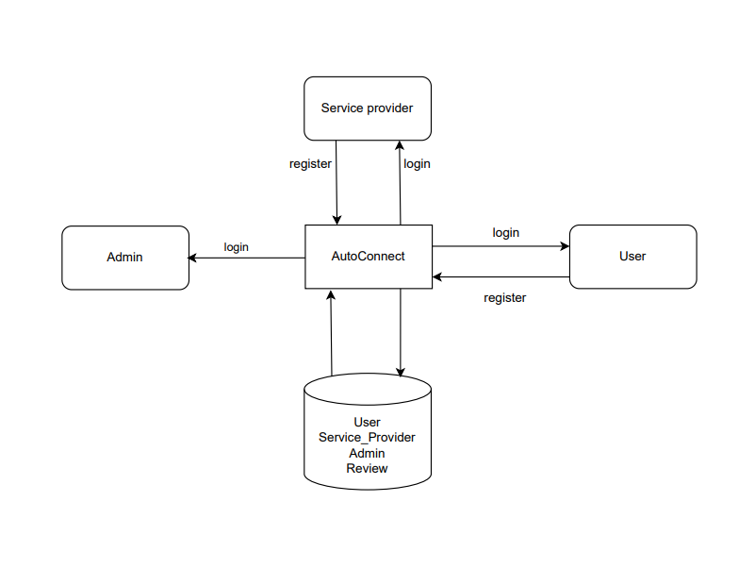

***Fig5.1****.* ***System Architecture***

The core of the **Auto Connect** system is its **centralized digital platform**, which functions as the sole intermediary for all interactions between the three key external entities: the **User**, the **Service Provider**, and the **Admin**. This architecture ensures a controlled and unified service management environment. The system's operational flow begins with the **Service Provider** and the **User** initiating a connection by submitting a **registration** request to the **AutoConnect** hub. Upon successful **login**, all entities gain access to their respective functionalities. Users engage with the platform to search, book, and submit **Reviews**, while Service Providers manage their listings, services, and bookings. Crucially, the **Admin** role enforces **authenticity and reliability** by vetting and approving new Service Providers, thus governing the integrity of the platform’s ecosystem. All transactional and master data—including **User**, **Service_Provider**, **Admin**, and **Review** records—are managed and permanently stored within a dedicated **Database**, which is constantly read from and written to by the **AutoConnect** application to execute all business logic and maintain the system's operational state. This centralized data handling and strict access control define the foundational structure that allows the platform to function as a unified service management solution.

## 

## 5.1 Presentation Layer (Frontend)

In the AutoConnect - SVSCL, the presentation layer serves as the user interface, enabling smooth interaction between users and the system. It allows customers, service providers, and administrators to perform their respective tasks efficiently through intuitive dashboards and web pages.

Customers use the front-end to register, log in, book services, make payments, and provide ratings. Service Providers use it to view bookings, manage appointments, update service statuses, and view feedback. Administrators use the front-end to approve new service centers, monitor system activities, and manage overall operations.

This layer simplifies complex backend operations by presenting data in an easy-to-understand format using forms, tables, charts, and alerts. It ensures proper input validation before data is sent to the server. Technologies such as HTML, CSS, JavaScript, and responsive frameworks like Bootstrap or Tailwind CSS are used to enhance usability and accessibility across devices.

The presentation layer thus acts as a bridge between users and the system, ensuring a user-friendly, efficient, and visually appealing interface.

## 5.2 Application Layer (Backend)

The application layer of the SVSCL serves as the bridge between the presentation layer and the data layer, managing system logic, process flows, and decision-making. It interprets user requests, validates them, processes business logic, and interacts with the database to retrieve or update information.

For customers, this layer enables account authentication, booking creation, and review submission. For service providers, it handles schedule management, service updates, and booking confirmations. For administrators, it facilitates approval of service providers, user management, and report generation.

The application layer ensures secure authentication, session management, and role-based access control, preventing unauthorized access. It also handles workflow automation, ensuring that updates made by one entity (e.g., a service provider marking a booking as completed) are immediately reflected in related components.

Technologies supporting this layer include web frameworks like Django or Flask (Python), with RESTful APIs used to facilitate communication between the front-end and back-end.

Overall, the application layer ensures that the system remains responsive, secure, and scalable, supporting the operational goals of the SVSCL

## 5.3 Data Layer (Database)

## The data layer forms the foundation of the Service Center Management System, responsible for storing, retrieving, and managing all operational data. It ensures data integrity, accuracy, and security across all user interactions.

This layer contains several key tables such as User, Service Center, Booking, Review, and Admin.

* The User table stores customer information like username, contact details, and login credentials.
* The Service Center table holds service provider details, services offered, location, and approval status.
* The Booking table records booking details, including customer, service type, date, time, and status.
* The Review table manages customer feedback and ratings.
* The Admin table stores administrative credentials and logs system activities.

This layer ensures data consistency and referential integrity through relational constraints and employs security mechanisms like encryption and access control. Backup and recovery mechanisms ensure data reliability even in system failures.

The front-end interacts with this layer via the application layer using structured queries or ORM frameworks to fetch or modify data securely.

Overall, the data layer ensures that all components of the SVSCL function cohesively, maintaining accuracy, reliability, and security in service operations.

.

# CHAPTER 6

# MODULES

## 6.1 User Management Module

The **User Management Module** serves as the primary interface for vehicle owners who utilize the AutoConnect platform to locate and interact with nearby service centers. This module enables users to register, log in securely, and manage their personal profiles with ease. It forms the foundation of user interaction within the system, allowing individuals to access various services and maintain their vehicle-related data digitally.

Key features of this module include **user registration, authentication, and profile management**. Users can create accounts by providing essential details such as name, contact information, and vehicle data. Through this module, users can update their profiles, view booking history, and track ongoing service requests. The system ensures data privacy through **secure login credentials and encrypted data handling**, maintaining confidentiality and protecting sensitive information.

Overall, it serves as the foundation of AutoConnect’s interactive framework, promoting seamless communication between users and service centers while ensuring transparency and security in operations.

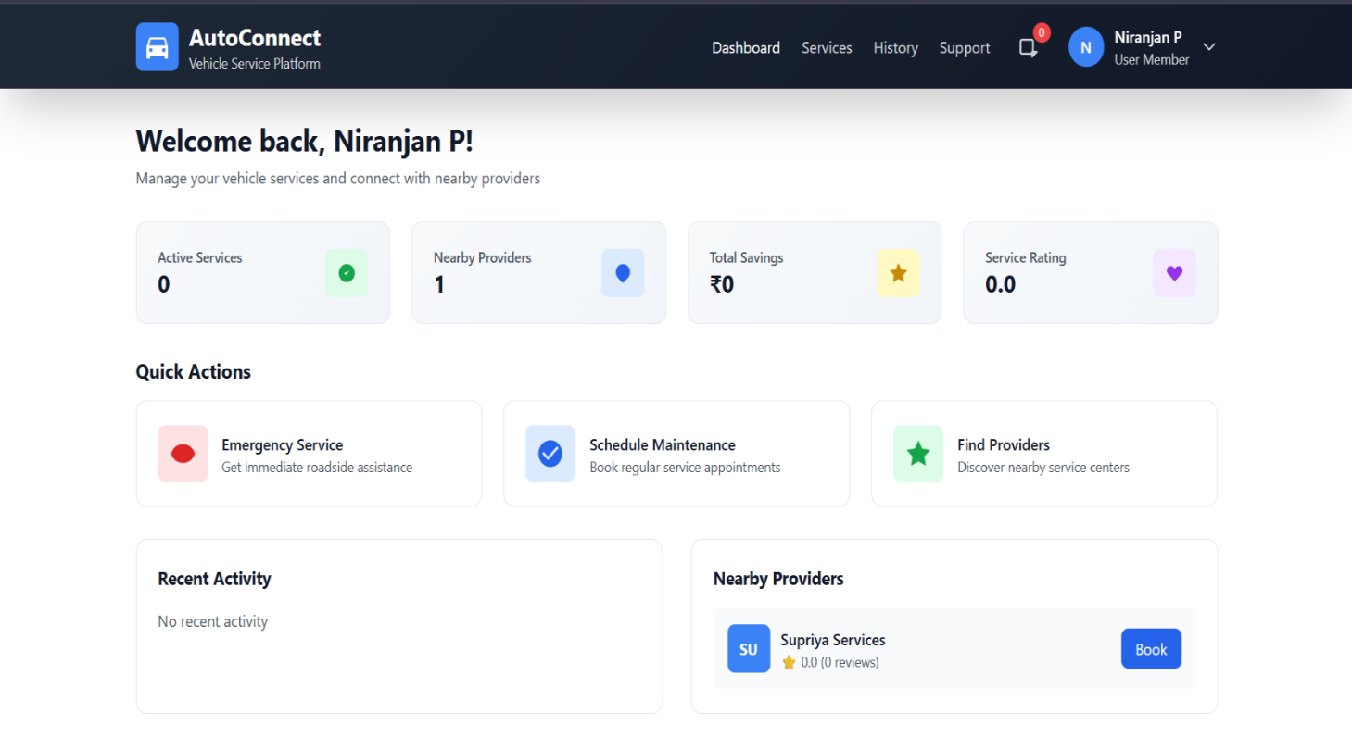

***FIGURE:6.1 USER MANAGEMENT MODULE***

## 6.2 Service Provider Module

The **Service Provider Module** is designed to assist service providers in efficiently managing their workshops, services, and customer interactions through the AutoConnect platform. It acts as the operational hub for service centers, enabling them to maintain an updated digital presence and streamline their administrative processes.

Core functionalities include **registration and authentication of service centers**, allowing verified providers to create and manage their profiles. Service centers can **list available services**, update pricing, specify working hours, and indicate real-time availability. The module also enables providers to receive and respond to booking requests, manage appointment schedules, and communicate directly with customers for confirmations or queries.

Furthermore, service providers can track customer reviews and ratings, allowing them to assess performance and improve service quality. The system ensures secure access through **role-based authentication**, enabling only authorized personnel to manage operations. By integrating these features, the Service Center Management Module enhances efficiency, transparency, and responsiveness, ultimately strengthening customer trust and satisfaction.

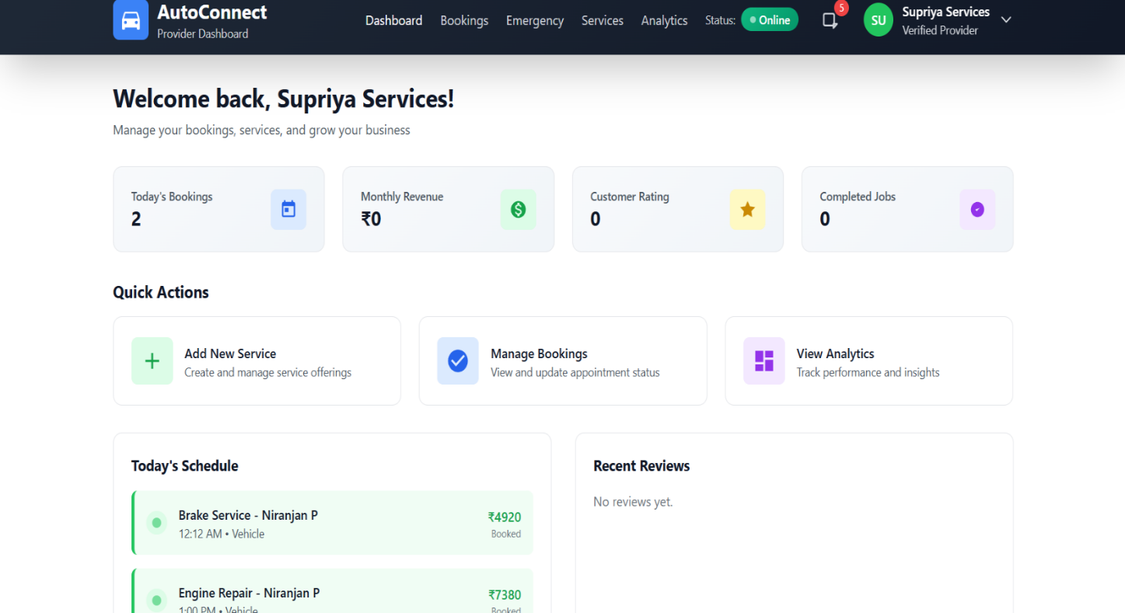

***FIGURE 6.2: SERVICE PROVIDER MODULE***

## 6.3 Booking & Scheduling Module

The **Booking & Scheduling Module** is a key operational component of AutoConnect that facilitates seamless appointment management between users and service centers. This module ensures that users can conveniently **book, modify, or cancel service appointments** while enabling service centers to **manage their schedules** effectively.Users can view the list of nearby service centers based on GPS location, select a suitable one, and choose preferred dates and times for their appointments. Once booked, the system automatically updates the service center’s availability and notifies both parties of the confirmed appointment. It also allows **real-time status tracking** of ongoing services, helping users stay informed about service progress.

From the service center’s perspective, the module simplifies workload management by preventing overbooking and ensuring optimal resource utilization. Automated notifications and reminders minimize missed appointments and delays. Overall, the Booking & Scheduling Module enhances operational efficiency, improves user convenience, and supports time-bound service delivery, which is central to AutoConnect’s objective of streamlined vehicle service coordination.

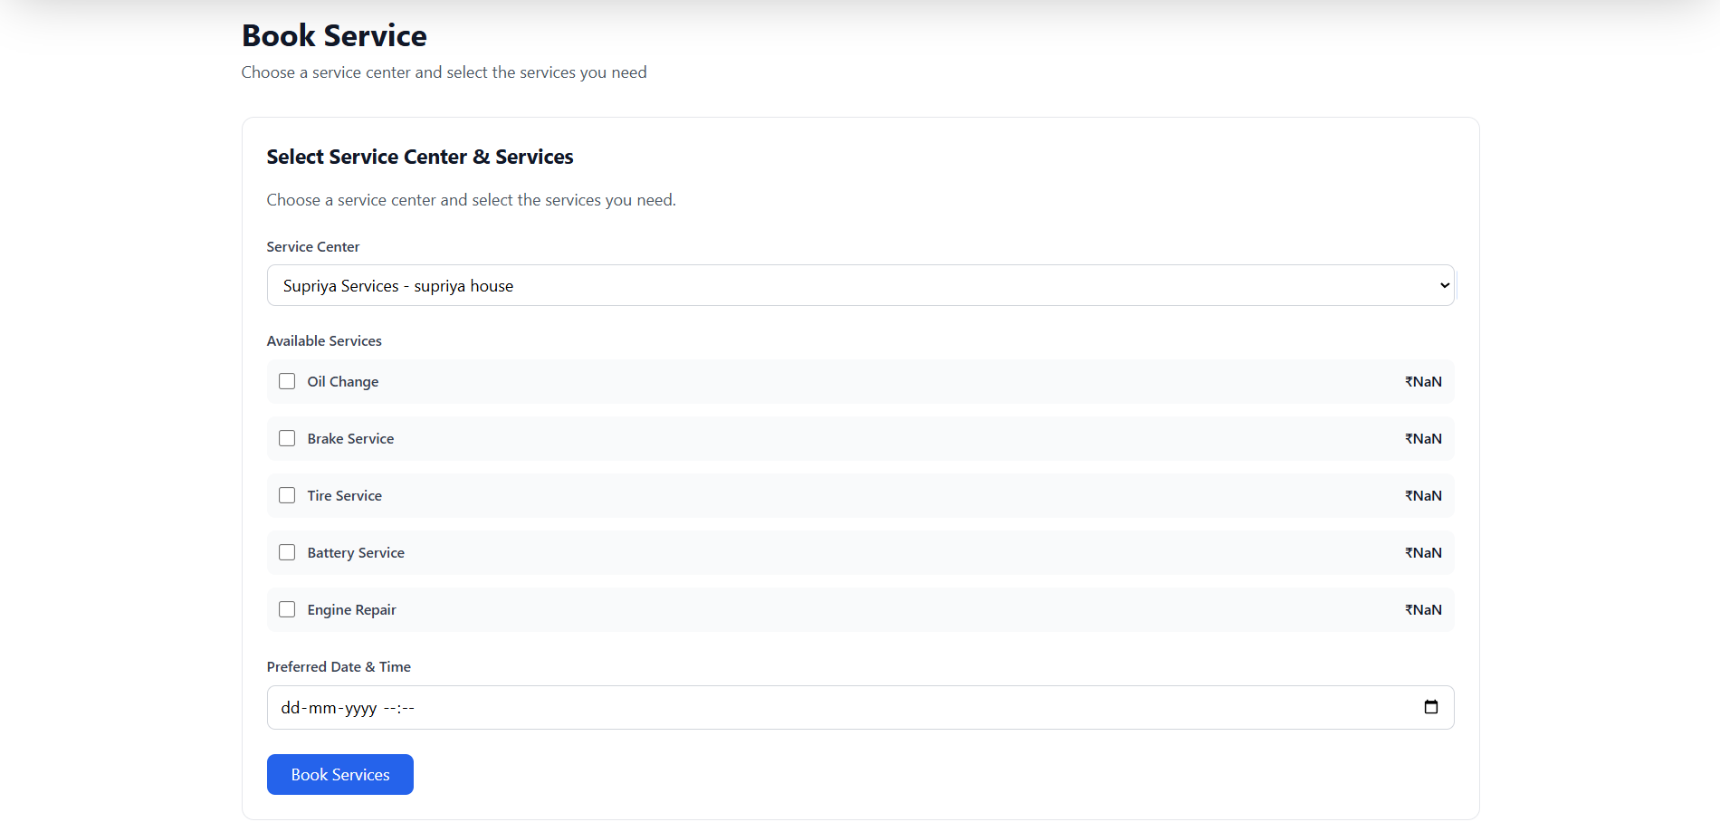

***FIGURE 6:3 BOOKING & SCHEDULING MODULE***

## 6.4 Admin Module

The **Admin Module** is the central control component of AutoConnect, responsible for overseeing all user and service center activities, maintaining data integrity, and ensuring smooth system operations. Administrators manage platform access, monitor service transactions, and handle system-wide updates to maintain functionality and security.

Key features of this module include **user and service center management**, **report generation**, and **system monitoring**. Admins can verify new service center registrations, resolve user complaints, and deactivate fraudulent accounts when necessary. The module provides administrators with comprehensive dashboards displaying real-time analytics on bookings, ratings, and system usage trends.

Additionally, the Admin Module ensures proper communication across all modules by disseminating notifications, handling escalations, and maintaining system performance. Through secure and role-based access, administrators can implement policies, review feedback summaries, and plan service improvements. Overall, the Admin Module is vital for maintaining platform transparency, ensuring data accuracy, and supporting efficient operation of the AutoConnect ecosystem.

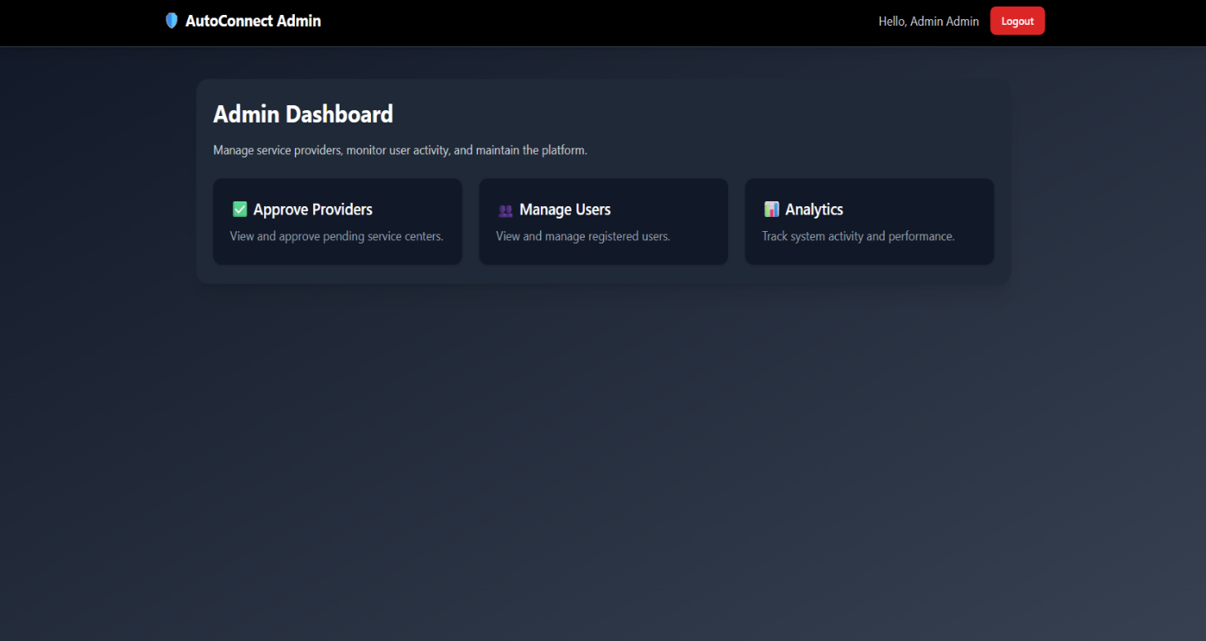

**FIGURE: 6.4 Admin Module**

# CHAPTER 7

# DIAGRAMS

## 7.1 Data Flow Diagrams (DFD)

A data flow diagram (DFD) is a graphical representation that shows how data moves within a system or organization. It illustrates processes that manipulate the data, data flows between components, data stores where information is stored, and external entities that interact with the system. DFDs are used to understand, analyze, and communicate information flow. They can be decomposed into different levels for a detailed view. The DFD is also called as a data flow graph or bubble chart. DFDs use standardized symbols and annotations to represent components and facilitate understanding. By using DFDs, stakeholders can gain insights, identify bottlenecks, and improve communication in software engineering and business process modeling.

### 7.1.1 LEVEL 0 DFD

A Level 0 DFD is also called Context Diagram. It provides a high-level overview of the system or organization, illustrating the major processes and their interconnections. It represents thetop- level view of data flow without delving into the internal workings of individual processes. The main purpose of a Level 0 DFD is to provide a conceptual understanding of how data moves through the system. It's important to note that a Level 0 DFD is often the starting point for creating more detailed DFDs. As the analysis progresses, additional levels (such as Level 1, Level 2, and so on) can be developed to further decompose the main process into sub-processes and provide a more detailed representation of the system's functionality.

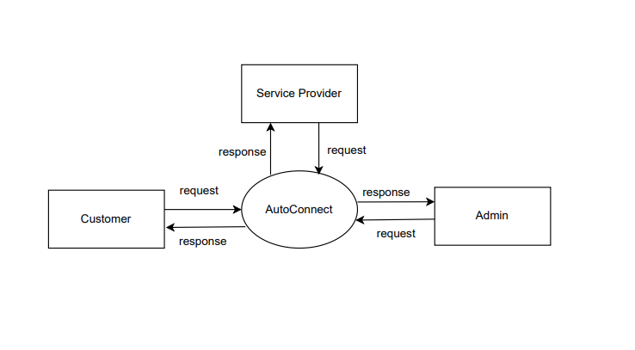

***FIG: 7.1 LEVEL 0 DFD***

###### 

## 7.1.2 LEVEL 1 ADMIN

## 

The Level 1 Data Flow Diagram for the Admin module in the Smart Vehicle Service Center Locator illustrates how the administrator oversees and manages the overall functioning of the system. The administrator begins by logging into the system, where the credentials provided are verified against the Admin Data Store. Upon successful authentication, the admin is granted access to manage all users of the system, including customers and service center personnel. The administrator is responsible for overseeing the registration and updates of service centers, ensuring that all service-related information is accurate and up to date, and approving or rejecting any new service center applications. In addition, the admin monitors the service requests submitted by customers, tracking their progress and ensuring that they are appropriately assigned to the relevant service centers for timely execution. The administrator also generates comprehensive reports on service requests, service center performance, and customer feedback, which aid in performance analysis and informed decision-making. All activities, updates, approvals, and generated reports are systematically stored in the respective data stores, including User Data, Service Center Data, Request Data, and Report Data, maintaining the integrity and reliability of the system.

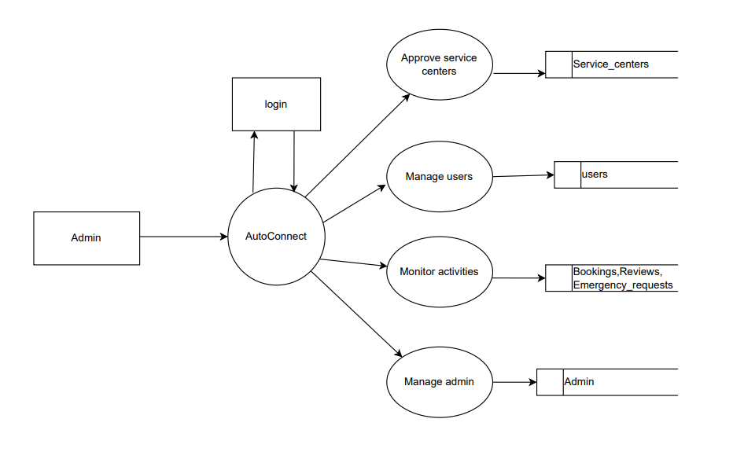

***FIG: 7.2 LEVEL 1 ADMIN***

## 7.1.3 LEVEL 1 USER

The Level 1 Data Flow Diagram for the User module in the Smart Vehicle Service Center Locator illustrates how customers interact with the system in detail. Users begin by registering or logging into the system, where their credentials are verified and maintained in the User Data Store. Once logged in, they can search for nearby service centers, view available services, and request vehicle maintenance or repair based on their needs. Users can also track the status of their service requests, make payments for completed services, and provide feedback or ratings for the service received. The system processes these requests, updates the relevant databases, and sends notifications, updates, or confirmations back to the user. The admin reviews and manages service assignments and approvals, ensuring requests are handled efficiently, and the system communicates updates to the users accordingly. Overall, this DFD emphasizes the flow of data between the user, the system, and the associated data stores, ensuring transparent, timely, and efficient vehicle service management.

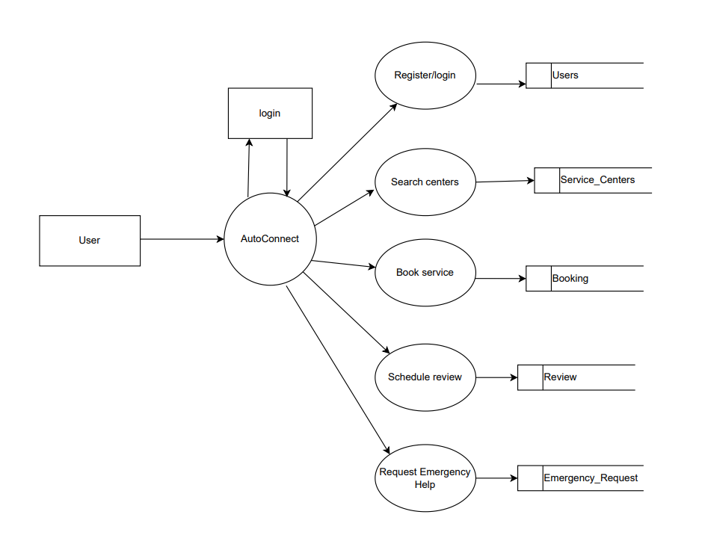

***FIG: 7.3 LEVEL 1 USER***

## 7.1.4 LEVEL 1 SERVICE PROVIDER

The Level 1 Data Flow Diagram for the Service Center module in the Smart Vehicle Service Center Locator illustrates how service centers interact with the system to manage vehicle service requests efficiently. Service center staff begin by logging into the system, where their credentials are verified using the Service Center Data Store. Once authenticated, they can view and accept assigned service requests from customers, update service progress, and record details of completed maintenance or repairs. Service center staff can also manage the availability of services, update pricing and service details, and communicate any delays or issues to customers through the system. All service updates, records, and communications are processed and stored in the Request Data Store and Service Center Data Store for accurate tracking and future reference. In return, service center personnel receive notifications of new requests, customer feedback, and administrative instructions. This DFD highlights the systematic flow of service-related data, ensuring timely, transparent, and organized interactions between service centers, customers, and administrators for effective vehicle service management.

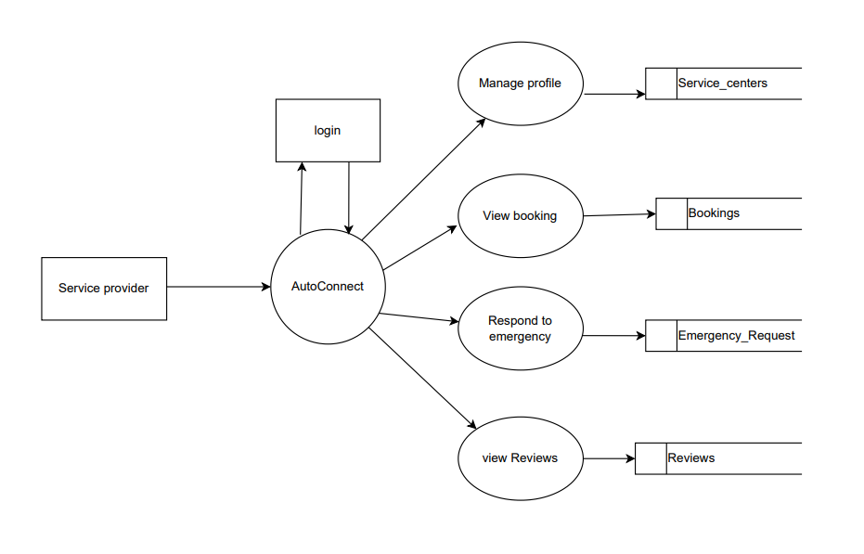

***FIG: 7.4 LEVEL 1 SERVICE PROVIDER***

## 7.2 ER DIAGRAM

The Entity–Relationship (ER) Diagram of the Smart Vehicle Service Center Locator represents the logical structure of the database and the relationships between different entities within the system. The key entities include Admin, User, Service Center, Service Request, and Report. The Admin entity oversees the entire system, manages users and service centers, assigns service requests, and generates performance reports. The User entity stores information such as user ID, name, contact details, vehicle information, and service requests. The Service Center entity maintains details of service center ID, name, location, services offered, and availability, which link users and admins. The Service Request entity records all information regarding service requests, including request ID, service type, status, assigned service center, and completion details. The Report entity contains data on service performance, customer feedback, and service center efficiency. Relationships such as Admin manages Service Center, User requests Service, and Service Center updates Service Request define the connections between entities. This ER diagram ensures structured data organization and seamless interaction among all system components, facilitating efficient vehicle service management.

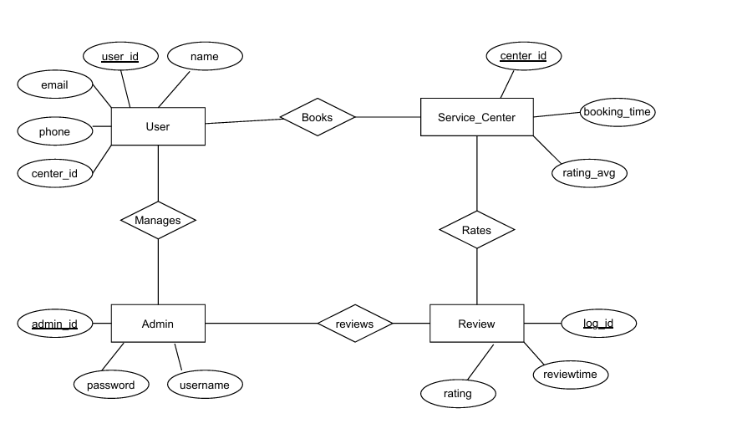

***FIG: 7.5 ER DIAGRAM***

## 7.3 USE CASE DIAGRAM

The Use Case Diagram of the Smart Vehicle Service Center Locator illustrates the interactions between different users — Admin, User, and Service Center — and the main functionalities of the system. The User actor can register, log in, search for service centers, request vehicle maintenance or repair, track service request status, make payments, and provide feedback on completed services. The Service Center actor can log in, view assigned service requests, update service progress, manage service details, and communicate updates to users. The Admin actor manages users and service centers, assigns service requests, approves new service center registrations, and generates performance and feedback reports. The use cases are connected through associations that indicate which actor performs each action. The diagram also includes relationships such as extends, for optional actions like providing feedback, and includes, for mandatory steps such as login. Overall, the use case diagram provides a comprehensive overview of the system’s functional requirements and clearly shows how each user interacts with the core features of the Smart Vehicle Service Center Locator.

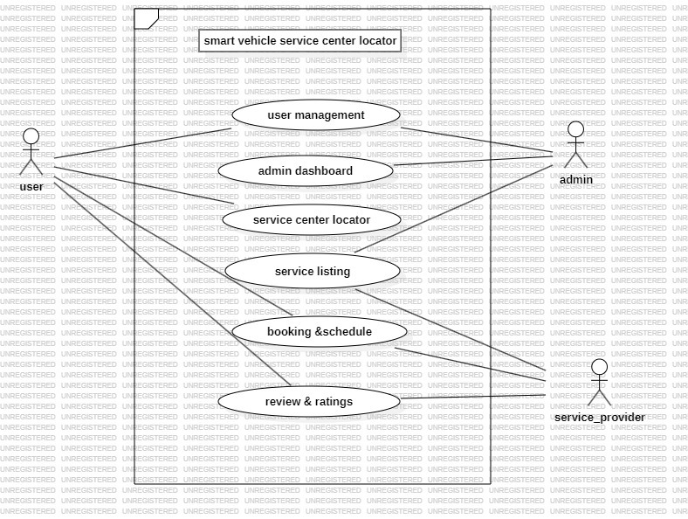

***FIG: 7.6 USE CASE DIAGRAM***

## 7.4 CLASS DIAGRAM

The Class Diagram of the Smart Vehicle Service Center Locator represents the structure of the system by showing the main classes, their attributes, methods, and relationships. The key classes include Admin, User, Service Center, Service Request, and Report. The Admin class manages users and service centers, assigns service requests, and generates performance and feedback reports. The User class allows customers to register, create service requests, track request status, make payments, and provide feedback. The Service Center class manages service details, updates the status of assigned service requests, and communicates with users regarding service progress. The Service Request class contains information such as request ID, service type, status, assigned service center, and completion details, while the Report class stores data on service performance, user feedback, and service center efficiency.

Relationships between classes include associations like Admin manages Service Center, User requests

Service, and Service Center updates Service Request. This diagram provides a clear understanding of how different entities interact and share information, ensuring an organized, object-oriented structure for efficient implementation of the Smart Vehicle Service Center Locator.

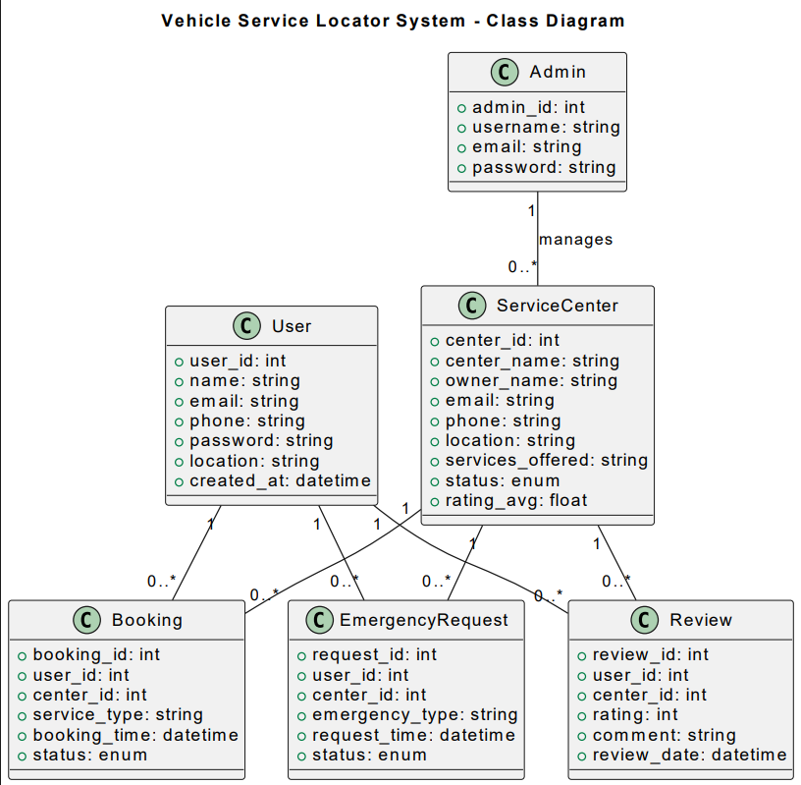

***FIG: 7.7 CLASS DIAGRAM***

# CHAPTER 8

# TESTING

## 8.1. Unit Testing:

Unit testing focuses on individual modules or components to ensure they work correctly. In a CHWMS, this could mean testing the citizen registration module, appointment booking feature, or health record update function independently. For example, checking if a new citizen’s data is correctly stored or if BMI calculation works accurately. It ensures that each part functions as expected before integration**.**

## 8.2. Integration Testing:

Integration testing verifies that multiple modules work together seamlessly. For instance, when a health worker updates vaccination data, the system should automatically update the citizen’s record and trigger notifications. Similarly, the admin’s reporting module must correctly fetch and combine data from various sources. This testing ensures smooth communication between modules.

## 8.3. System Testing:

System testing evaluates the entire CHWMS as a whole against functional requirements. It tests workflows like citizen registration, health worker service updates, appointment scheduling, and report generation. This ensures that all components operate together correctly and the system meets expected performance standards.

## 8.4. Acceptance Testing:

Acceptance testing ensures that the system fulfills stakeholder requirements. Citizens should be able to access only their records, health workers should manage patients efficiently, and admins should generate accurate reports. This step validates the system from a user’s perspective before deployment.

## 8.5. Performance Testing:

Performance testing checks how the system behaves under load. For example, the system should handle multiple citizen registrations simultaneously without delay. This ensures reliability.

## 

## 8.6. Security Testing:

Security testing safeguards sensitive data such as medical records. It includes testing user authentication, role-based access, and data encryption to prevent unauthorized access or breaches.

## 

## 8.7. Usability Testing:

Usability testing evaluates user-friendliness. Citizens should navigate the system easily to book appointments or view services, while health workers and admins should perform their tasks efficiently with minimal training.

# CHAPTER 9

# ADVANTAGES & DISADVANTAGES

## 9.1 Advantages

1 Seamless **Connectivity:**

AutoConnect enables automatic linking between user devices and nearby service centers without requiring manual configuration. This helps users easily access services and information about their vehicle’s maintenance status with minimal effort.

2 Real**-Time Data Sharing:**

The feature allows real-time transmission of vehicle-related data such as service alerts, mileage, and engine health. This ensures that the service centers receive updates instantly and can respond to the user’s needs quickly.

3 Enhanced **User Experience:**

By removing the need for repeated login or setup, AutoConnect provides a smooth and user-friendly experience. Users can automatically connect to trusted service providers as soon as they are nearby.

4 Faster **Service Response:**

With automatic connectivity, service centers can detect user requests or issues immediately and prepare for the service in advance. This reduces waiting time and improves overall service efficiency.

5 Improved **Safety and Convenience:**

AutoConnect can automatically notify users about important updates like upcoming maintenance schedules, low fuel, or system malfunctions. This ensures the safety and reliability of the vehicle while keeping users informed at all times.

## 9.2 Disadvantages

1 Security **Risks:**

Since AutoConnect establishes automatic connections, it can become a target for unauthorized access or hacking if not properly secured. Sensitive vehicle and user data may be exposed.

2 Privacy **Concerns:**

Continuous sharing of vehicle location and user information with connected service centers may lead to privacy issues if data is not handled responsibly.

3 Dependence **on Connectivity:**

The functionality of AutoConnect relies heavily on stable internet or Bluetooth connections. Poor network conditions may lead to disconnections or failed updates.

4 Higher **Power Consumption:**

Maintaining constant background connectivity may result in increased battery usage on the user’s device, especially if GPS and data services are always active.

5 Compatibility **Limitations:**

AutoConnect may not be supported across all vehicles, smartphones, or network environments. This can cause inconsistent performance or restrict its use to specific models or platforms.

# CHAPTER 10

# RESULTS

The AutoConnect – Smart Vehicle Service Center Locator system was developed to simplify and automate the process of locating, booking, and managing vehicle service requirements. The project integrates multiple modules that work together to create a seamless experience for users, service providers, and the administrator. The following section presents a detailed result analysis along with specific observations for each module.

## 10.1 User Registration and Authentication Analysis

This module allows users and service providers to register and log in to the system with role-based access control. Passwords are securely encrypted, and only verified users are allowed to log in. The system ensures proper validation, preventing duplicate accounts and unauthorized access. Login and logout functionalities worked accurately during testing.

Observations:

* The registration and authentication process was smooth and secure for both users and providers
* Error handling for invalid credentials and missing fields worked effectively.
* The redirection to respective dashboards after login was accurate.
* User sessions were maintained properly and terminated correctly after logout.

## 10.2 Service Provider Module:

Service providers can register their workshops, manage their profiles, update service lists, view bookings, and respond to customer requests. They can also mark services as completed, add pricing, and update the booking status dynamically.

Observations:

* Providers could successfully edit their details and update service offerings.
* Booking statuses were updated instantly upon acceptance or completion.
* Provider dashboards accurately reflected total bookings and earnings.
* Data synchronization between provider and user views was error-free.

## 10.3 User Module:

The user module allows customers to browse nearby service centers, view ratings and reviews, and book services easily. They can also track booking status, cancel services if necessary, and provide feedback once completed.

Observations:

* Booking details were stored accurately and displayed correctly in the dashboard
* Cancellation and rescheduling functionalities worked smoothly.
* Review submission was recorded instantly and displayed on the provider’s page.
* The UI was intuitive and responsive.

## 

## 10.4 Service Booking Module:

This module enables users to book appointments with service centers for specific dates and service types. The system prevents double booking and ensures time-slot management for service providers.

Observations:

* Bookings were successfully created and reflected on both user and provider dashboards
* Status updates like Pending, Accepted, and Completed were displayed in real time.
* Booking clashes were effectively avoided using time validation.

## 10.5 Emergency Assistance Module:

This feature allows users to instantly connect with nearby workshops in case of sudden breakdowns or emergencies. It provides real-time assistance without needing to go through the regular booking process.

Observations:

* Emergency assistance requests were transmitted instantly to nearby service centers.
* Users received accurate contact information of nearby workshops.
* The feature worked smoothly with minimal delay.

# CHAPTER 11

# CONCLUSION & FUTURE SCOPE

**11.1 CONCLUSION**

In conclusion, the **"Auto Connect - Smart Vehicle Service Center Locator"** project has successfully culminated in the creation of a powerful and unified digital platform. Fundamentally, this solution addresses a critical need in the modern automotive landscape by **bridging the historical gap** between vehicle owners and reliable service providers. The core achievement lies in the streamlined user experience: the platform significantly **simplifies the entire process of booking, tracking, and managing** vehicle maintenance and repair services. By consolidating disparate search, scheduling, and communication functions into a single, intuitive interface, Auto Connect ensures that users can manage their vehicle services with unprecedented **efficiency and convenience**, transforming a traditionally cumbersome experience into a seamless digital interaction.

Beyond mere functionality, the platform's robust design emphasizes authenticity and trust. A cornerstone of the system is the **mandatory Admin approval process**, which acts as a crucial quality gate, ensuring the **authenticity and reliability** of every registered service provider. This centralized validation provides users with confidence in the quality of service they receive. Crucially, the platform fosters a new standard of service delivery by greatly improving **transparency**—through clear service descriptions and pricing—and enhancing **communication** tools between the user and the service center. The resulting effect is a marked improvement in **overall user satisfaction**, validating the project's goal of leveraging technology to solve genuine, real-world consumer problems.

From a technical standpoint, the successful deployment of Auto Connect demonstrates a highly **effective and practical use of modern web technologies** and database management to solve complex logistical challenges. The project proves that a single, integrated digital solution can effectively manage complex service supply chains while prioritizing the end-user experience. Looking ahead, the foundation established by this platform is exceptionally scalable. With future enhancements, which can include broader service integrations, payment gateways, and advanced analytics, the **"Auto Connect" platform is poised to evolve** from a simple locator tool **into a complete, holistic vehicle service management ecosystem**, setting a new benchmark for smart automotive support.

**11.2 FUTURE SCOPE**

The path of Smart Vehicle Service Center Locator (SVSCL) is determined by the required progression to an intelligent, proactive ecosystem of vehicle management, which would go much beyond its current role of the mere location and booking tool. The given ambitious future scope can be primarily reduced to incorporating Advanced Predictive and Condition-Based Maintenance (CBM) features that begin with the profound architectural expansion of the Automatic Car Service Recommendation System (ref. 4) with complex Long Short-Term Memory (LSTM) models (ref. 7) as well as other machine learning algorithms (ref. 17). This intelligence core will work on the broad telematics data (ref. 12) (sensor readings, usage history, and driving patterns) to predict the component failure even before it has happened so that the system shifts to a more proactive CBM model automatic provision of fault-prediction alerts and service slotting as a result of predicted anomaly detection. In order to make this intelligence possible, one of the core future objectives is Comprehensive IoT and Telematics Integration that requires the extensive adoption of secure, bi-directional, communication protocols in deep-vehicle-data exchange, enabled by the integration of IoT-Based Vehicle Health Monitoring Systems (ref. 11) and the creation of uniform Vehicle-to-Infrastructure (V2I) data protocols (ref. 20).

This connectivity will provide real time usage data and error codes directly out of the vehicle OBD-II unit directly to the dashboard of the service center which will give the technicians all the diagnostic detail immediately a booking is made, and this meets the critical efficiency criteria which are demonstrated by the Integration of GPS in Emergency Service Vehicles (ref. 6). Moreover, to maximize the benefits of seamless service delivery, the SVSCL will need to incorporate its decentralized Integrated Online Booking (IOB) system (ref. 8) into the wider supply chain; this should be the development of modules to Integrating E-Commerce and Logistics Supply Chain Auto Spare Parts (ref. 18) such that the prediction of a fault takes place, the platform automatically checks the availability of parts and provides procurement.

At the same time, the advanced Queuing Theory models (ref. 13) will allow the system to constantly optimize the Service Bay Allocation and technician scheduling in order to reduce service center congestion and turn the service logistics into the highly agile and demand-driven model. Importantly, in a bid to ensure user trust (ref. 9) and establish an irreversible record, one of the primary areas of future scope will be the Implementation of Decentralized Ledger Technology (Blockchain) (ref. 14), where all significant repair and maintenance measures will be cryptographically time-stamped and stored and thus there will be data asymmetry and will create a verifiable and auditable record that will maximize transparency and maximize vehicle resale values. Last but not least, the SVSCL will also be devoted to the improvement of technician support and user interaction with Augmented Reality and Advanced User Experience capabilities, such as the introduction of Remote Technical Assistance supported with AR (ref. 16) to the technicians, and Accessibility and Inclusivity (ref. 10) by adding voice-command controls and better support of the complex and data-rich features with localized languages to make everything complex and accessible to all citizens.

# APPENDICES

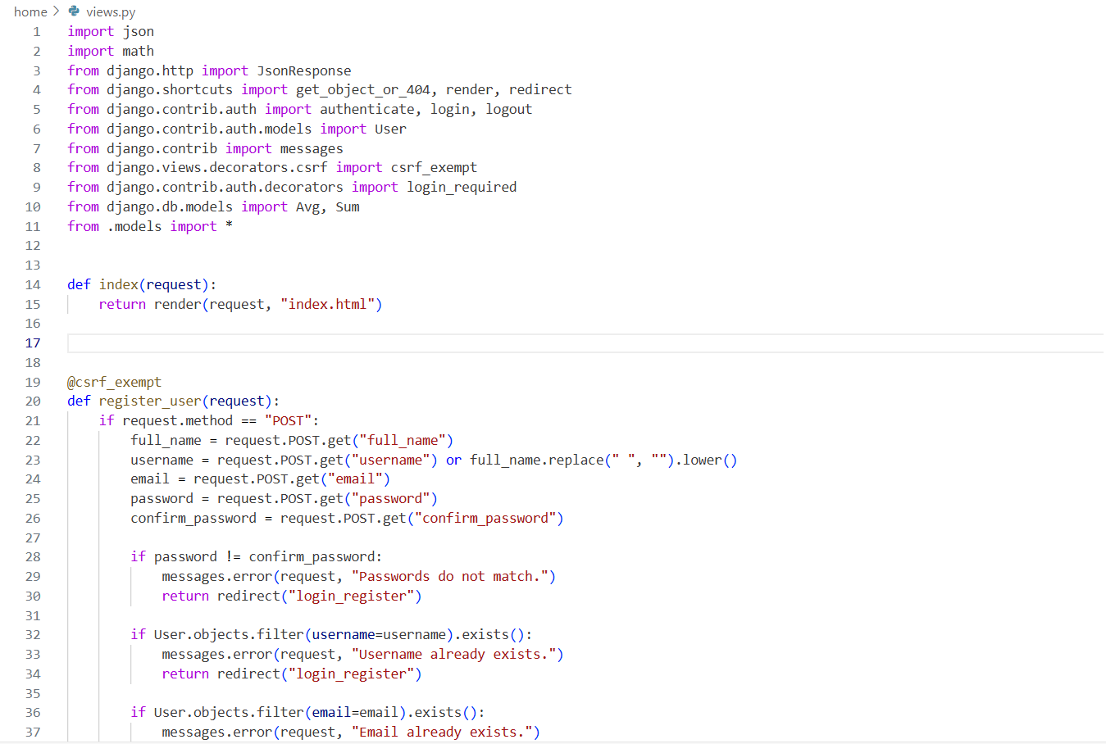

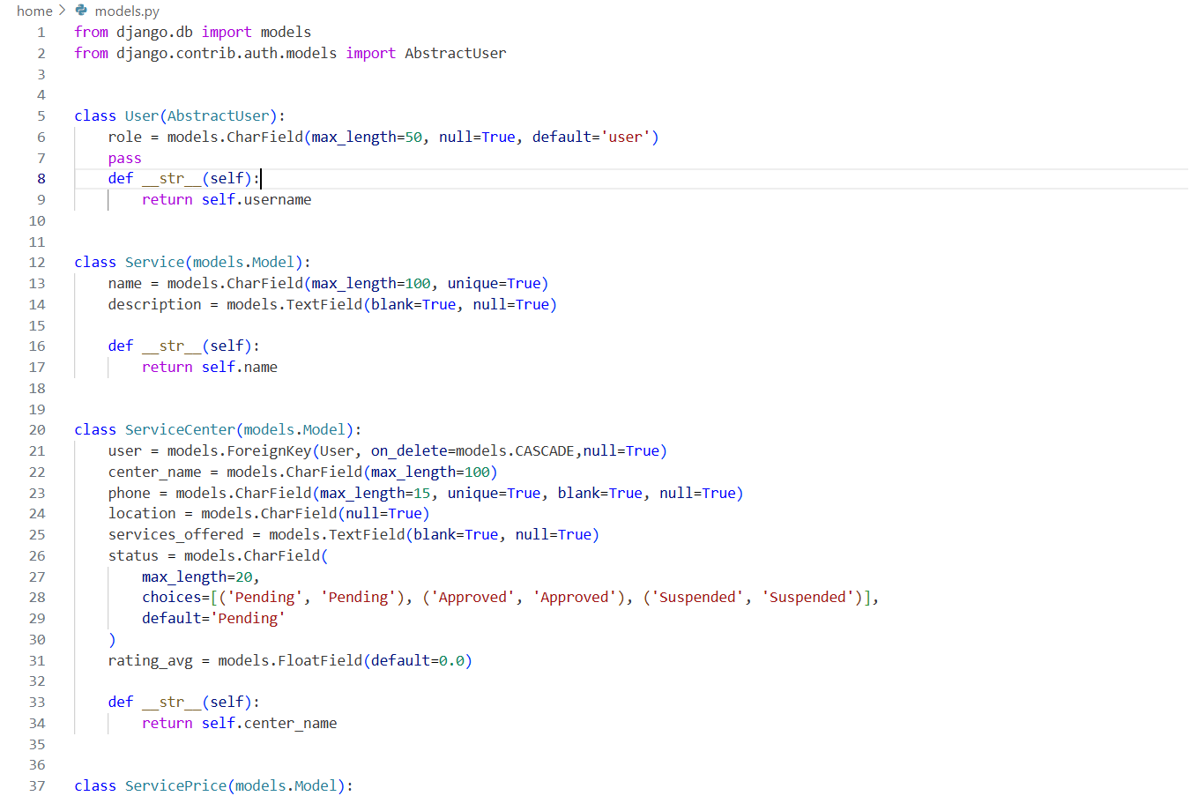

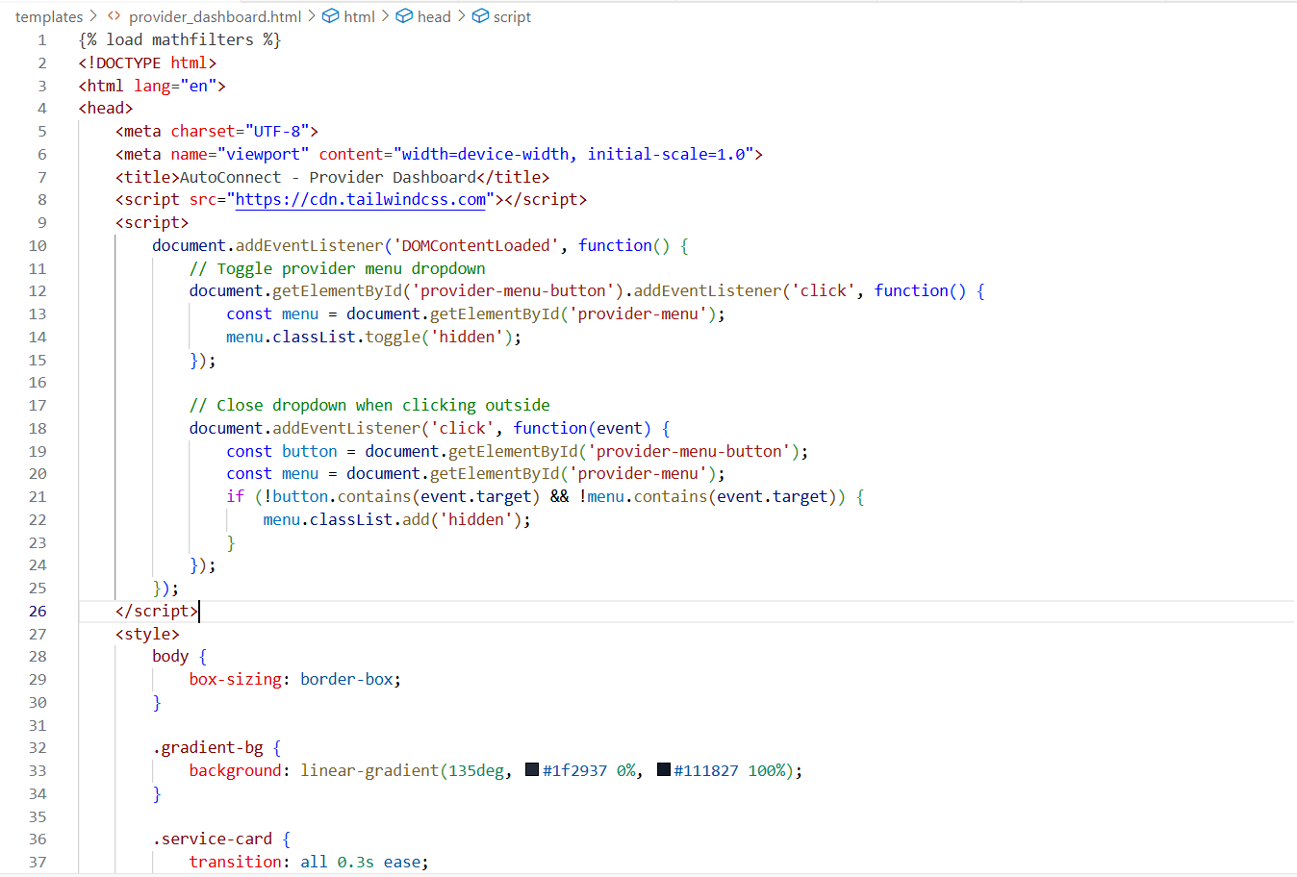

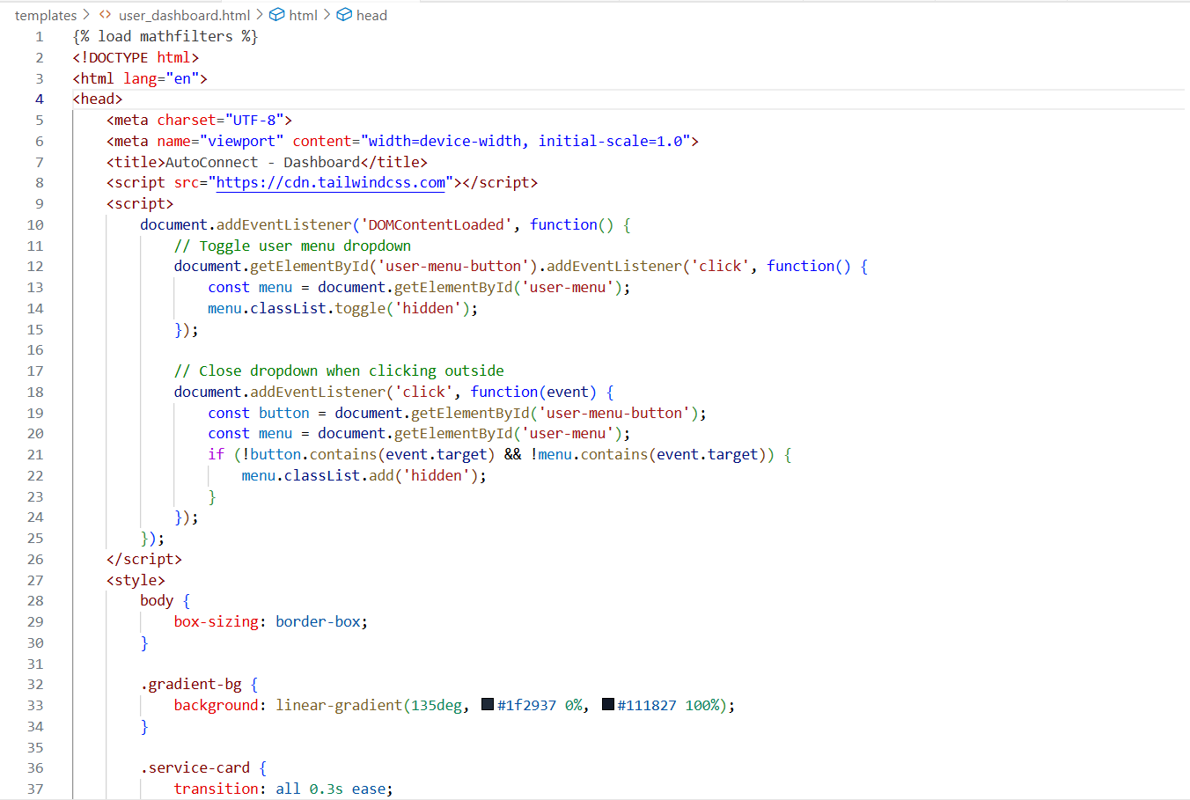

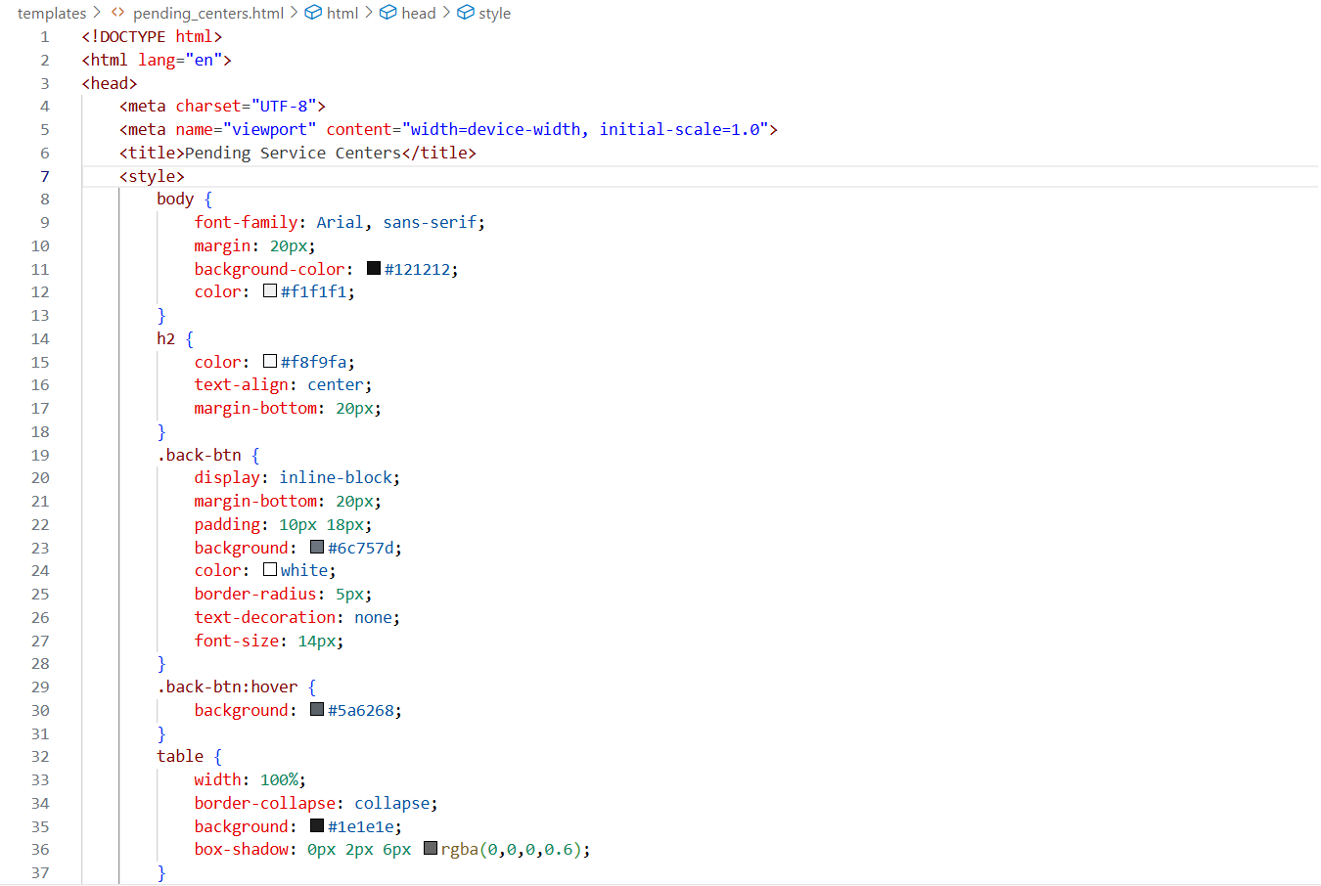

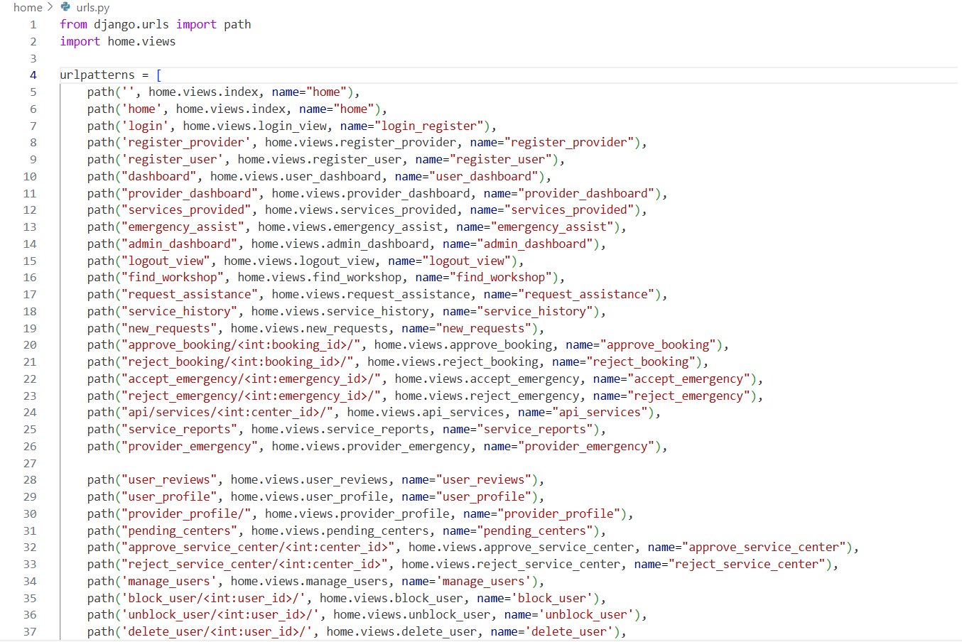

# REFERENCES

1. Swarali Degaonkar, Manasi Khillare, and Dr. Aarti Agarkar "Vehicle Service Automation" in IJARIIT, 2023.
2. Laxman Krishnan, Arathy S, and Haritha K "GPS-Based Emergency Vehicle Detection System" in IJARIIT, 2021.
3. Sathwik Krishna L and Siva Rama Krishna S "Vehicle Breakdown Service Provider System" in IJSRCSEIT, 2021.
4. M. A. R. Kumar and K.N. Rama Krishna "Automatic Car Service Recommendation System" in i-manager’s Journal, 2022.
5. Dinesh S. Bhadane and Pritam B. Bharati "Review on GSM and GPS Based Vehicle Tracking System" in ResearchGate, 2023.
6. Dr. Raghu R and Dr. Mala K. M "Integration of GPS in Emergency Service Vehicles" in IJARIIT, 2023.
7. Acharya, M "A Long Short-Term Memory (LSTM) approach for POI (Point-of-Interest) Recommendation" in ScienceDirect, 2023.
8. Seyedi, P "Introducing a decentralized integrated Online Booking (IOB) system" in ScienceDirect, 2024.
9. Rahman, Perez, others "The Impact of Reviews and Ratings on Customer Decisions" in BM Journal, 2024.

[10] S. Shankar Kumar, K.J. Vinodini "Assessing Accessibility and Inclusivity in Digital India

Services: A Citizen’s Perspective" in IIETA, 2024.

[11] Ramesh, P., & Kumar, S. "IoT-Based Vehicle Health Monitoring System" in International

Journal of Automation and Smart Technology, 2023.

[12] Chen, L., & Li, M. "Predictive Maintenance Scheduling via Telematics Data" in IEEE

Transactions on Industrial Informatics, 2024.

[13] Sharma, R., et al. "Optimization of Service Bay Allocation using Queuing Theory" in Journal

of Logistics and Supply Chain Management, 2022.

[14] Patel, V., & Singh, A. "A Decentralized Ledger for Vehicle Maintenance History (Blockchain)"

in International Conference on Smart Systems, 2023.

[15] Kaur, H., & Singh, K. "Customer Relationship Management (CRM) through Automotive Mobile

Applications" in Journal of Automotive Engineering, 2021.

[16] Das, B., & Menon, A. "Remote Technical Assistance using Augmented Reality (AR) in Vehicle

Repair" in International Journal of Virtual and Augmented Reality, 2024.

[17] Gupta, R., & Jain, S. "Machine Learning Approach for Automotive Fault Prediction" in

Expert Systems with Applications, 2022.

[18] Raj, P., & Rao, D. "Integrating E-Commerce and Logistics for Auto Spare Parts Supply Chain"

in Global Journal of Operations Management, 2023.

[19] Verma, A., & Mishra, L. "Factors Influencing Customer Satisfaction in Digital Automotive

Aftermarket Service" in Journal of Service Science and Management, 2024.

[20] Krishnan, M., & Narayanan, V. "Standardization of Vehicle-to-Infrastructure (V2I)

Data Protocols for Service" in IEEE Vehicular Technology Conference, 2023.



